Day 11-12: Linear Algebra for Machine Learning

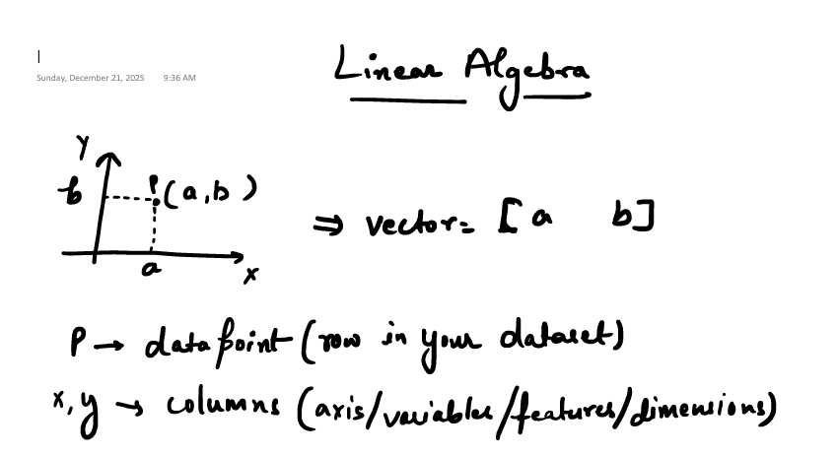

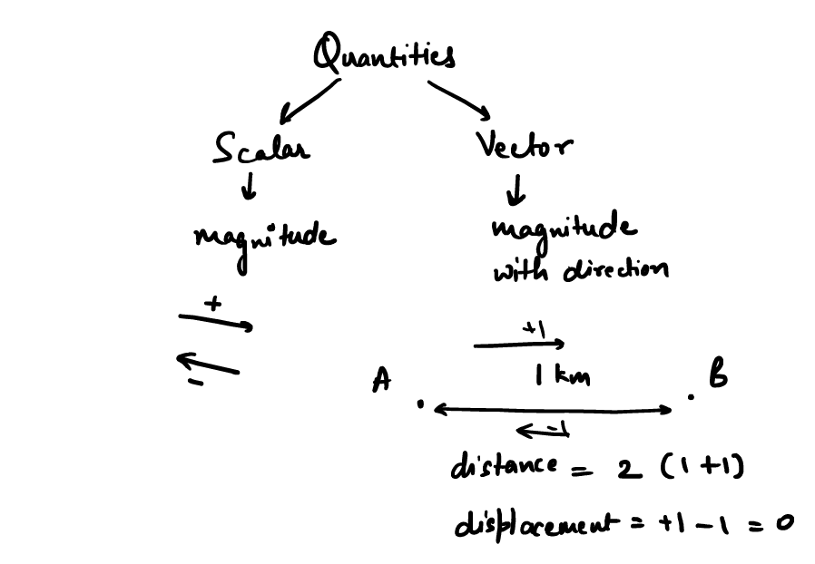
Displacement is about how much I have moved from my own place.
For direction,
if I move from Left to Right I mark it as +ve
If I move from Right to Left I mark it as -ve.

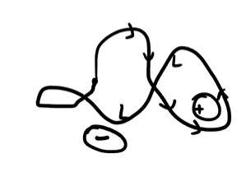
Displacement here is Zero.
Since the concept of direction came in, it is known as a Vector.
Velocity is a Vector, Speed cannot be negative but velocity can be negative.
Hence there is a speed of light but not the velocity of light.

Now how do I Show a vector,
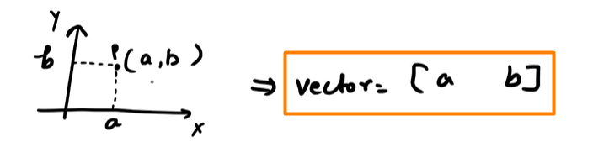

List: Could be of heterogenous data types
Array: A list of homogenous data types.

Vector in 3D:
The data which can move in 3-dimension, X, Y, Z.

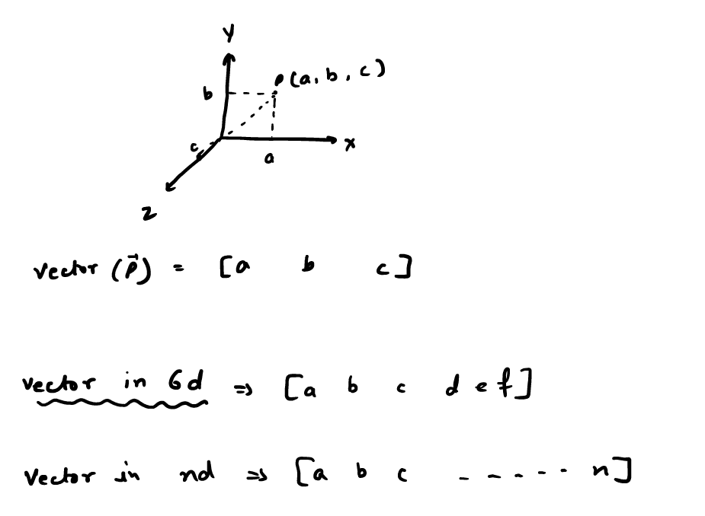

Matrix:

ssd

